FILE INVESTIGATION
26. Current directory
Cd (ki mai abhi kis folder mai kaam karri hun)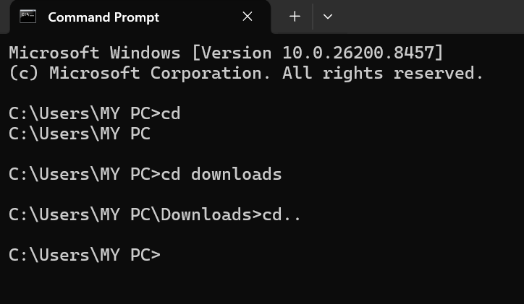
SOC POV
File investigation location.
- One folder back – cd ..
- Very begening – c:drive – cd \
- Move diffrenet folder – cd downloads

27. Files list karo
Dir (saari files list karta hai )
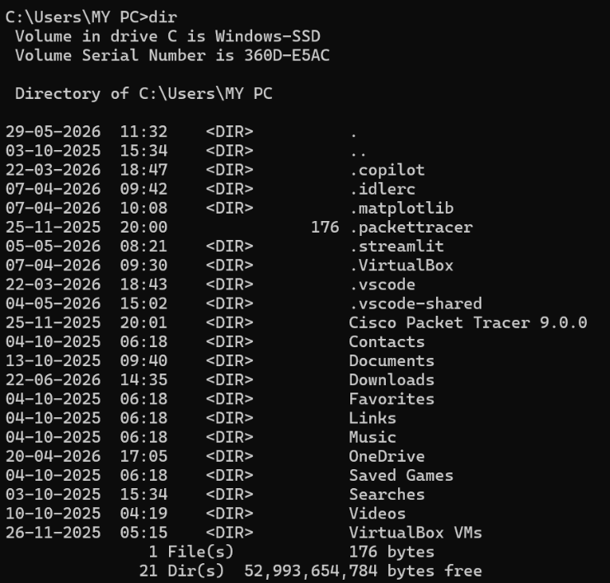
SOC POV
Suspicious file detect.

28. Hidden files show karo
dir /a
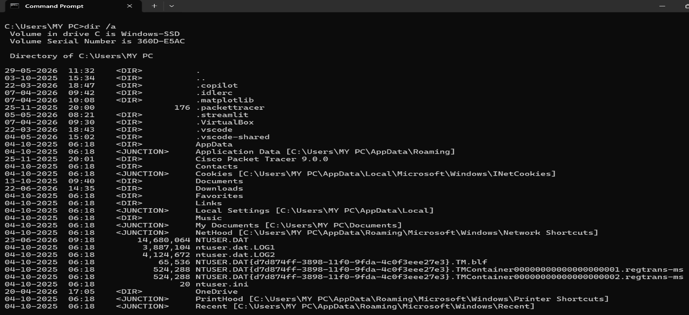
SOC POV
Malware hidden files.
- Ntuser.daT- Basically yeh store karta hai user register info(never delete this data cause deleting it correupt the system setting and problem in loading your profile)
- Ntyser log1 and log2- store change settings of register
- App data – store info about application
- Standers folder – music , download, pictures , vedios
Suspiucious –
- Exe files in user folder instead of folder 32
- Unexpected files name
- Exe , temp , dll files in your temp folder

29. File content read karo
type file.txt
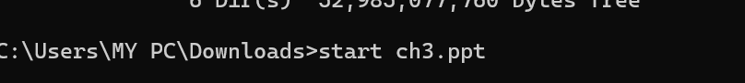
SOC POV
Malicious script analysis.
Pdf – start EHPT.pdf
Doosri file – start “” “prapti resume.docx”

30. Specific file search
dir *.exe (dir and * ke beech mai space)
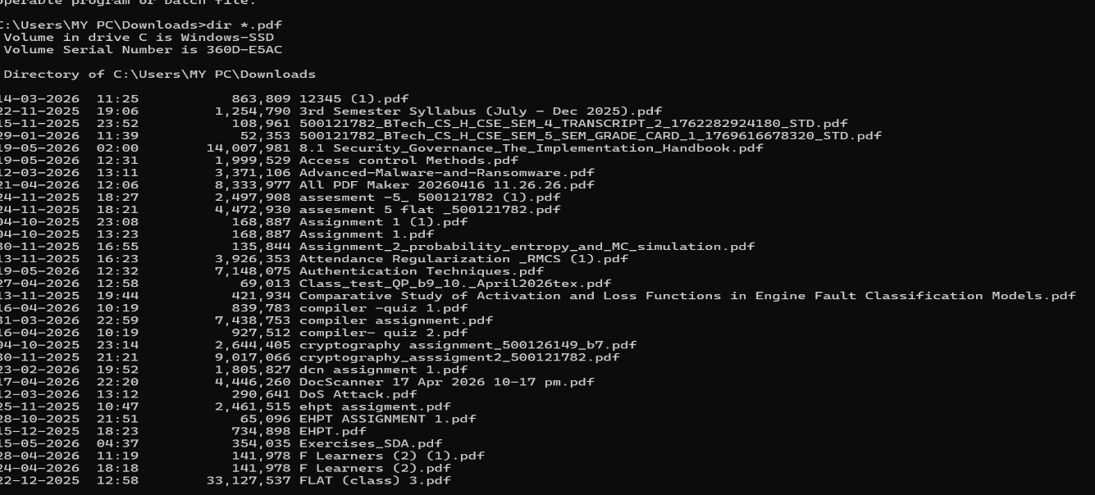
SOC POV
Unknown executables detect.
Dir *.pdf= all pdf files
Dir *.png = all png files
Die *.exe= all exe files

31. System32 folder explore

cd C:\Windows\System32
dir
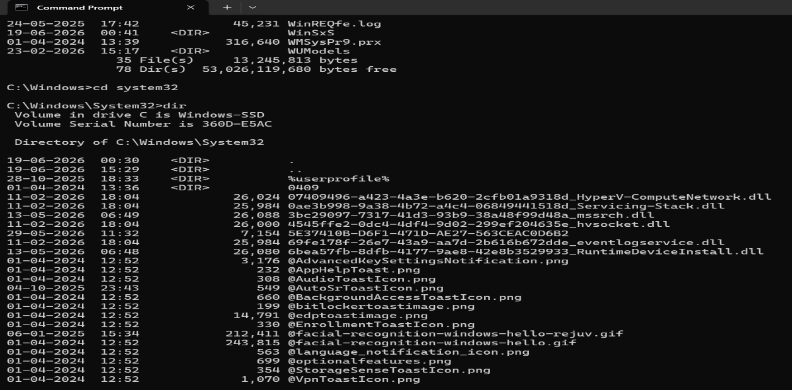
SOC POV
Critical system binaries

32. Temporary files check
cd C:\Temp
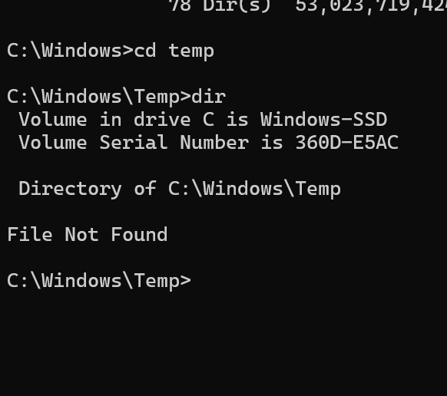
SOC POV
Malware drop location.

33. AppData folder check
cd C:\Users\username\AppData
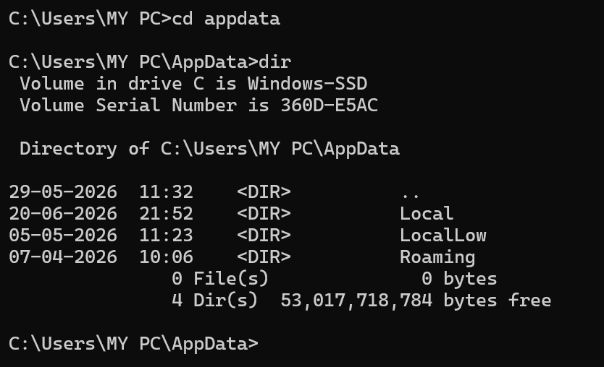
SOC POV
Malware persistence.

34. File creation date check
dir /T:C
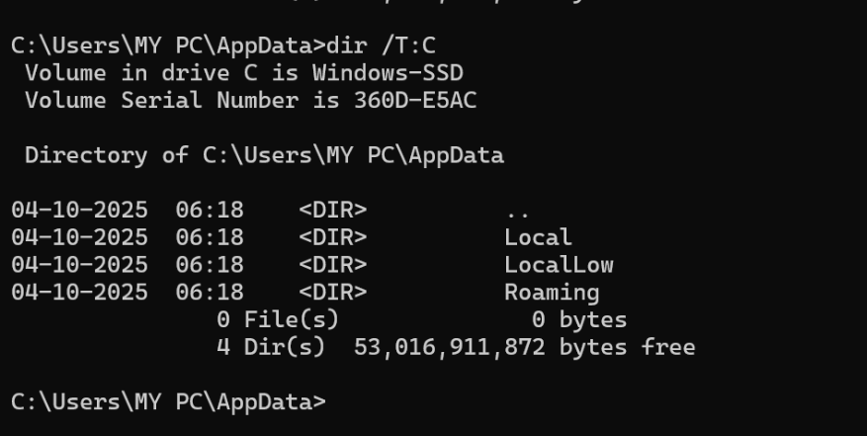
SOC POV
Attack timeline.

35. File delete
del malware.exe
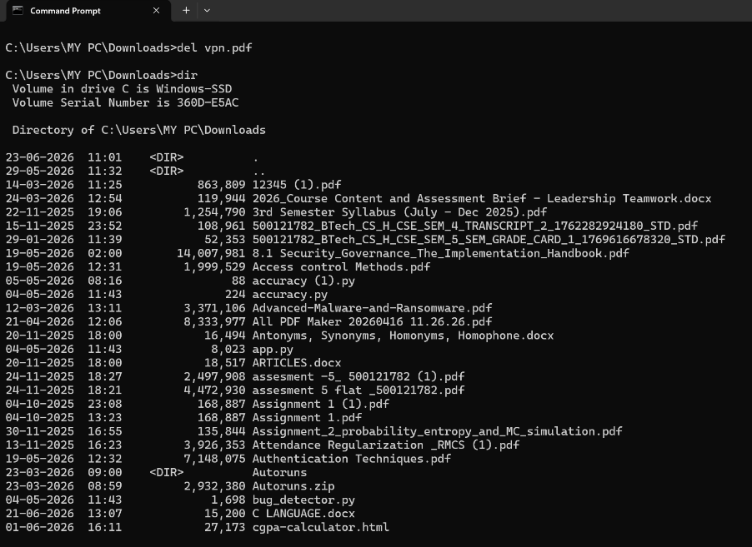
SOC POV
Malicious file removal.
C/ mai hote hai do folder users and widows
Windows mai hoti hai saari files
Users mai do folder my pc and public
Public mai music , pictures , documents and downloads
My pc mai public wale + aur bhi hote hai like app data vs code etc

